Question 1. Write an Auto Exposure Bracketing (AEB) function for Tegra (5 Points)

Answer:

Android Studio Codes

public void captureExposureStack(View v) {  
  
 //*TODO:hw4* //*TODO: Getting min and max exposures.* Range<Long> exposureRange = characteristics.get(CameraCharacteristics.*SENSOR_INFO_EXPOSURE_TIME_RANGE*);  
 Long minimumExposure = exposureRange.getLower();  
 Long maximumExposure = exposureRange.getUpper();  
 Log.*e*(*TAG*, "minimumExposure: " + minimumExposure);  
 Log.*e*(*TAG*, "maximumExposure: " + maximumExposure);  
 Long prevExposure = minimumExposure;  
 //check if 2* exposure >maximumExposure  
 while (prevExposure + prevExposure < maximumExposure) {  
 try {  
 //sleep the system for 20ms between each capture.  
 SystemClock.*sleep*(20);  
 Log.*e*(*TAG*, "exposure: " + prevExposure);  
 //*TODO:update exposure time* prevExposure = prevExposure+prevExposure;  
 //create capture requester  
 CaptureRequest.Builder requester = mCameraDevice.createCaptureRequest(mCameraDevice.*TEMPLATE_MANUAL*);  
 //*TODO: set requester exposure time* requester.set(CaptureRequest.*SENSOR_EXPOSURE_TIME*,prevExposure);  
 //add surface  
 requester.addTarget(mCaptureBuffer.getSurface());  
 Log.*e*(*TAG*, "exposure: " + prevExposure);  
 //check capture session and make capture request  
 if (mCaptureSession != null)  
 exposures.add(prevExposure);  
 mCaptureSession.capture(requester.build(), null, null);  
 } catch (CameraAccessException e) {  
 Log.*e*(*TAG*, "Failed to build actual capture request", e);  
 }  
 }  
  
}

According to the standard of pixels value, six images are chosen which are as follows.

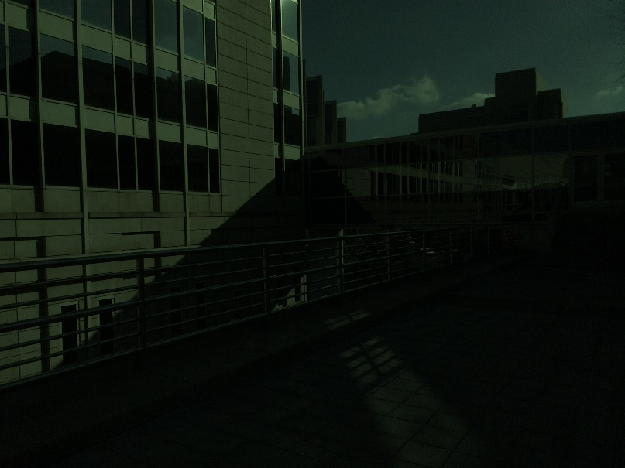

Figure 1. exposure time= 67200e-09 s

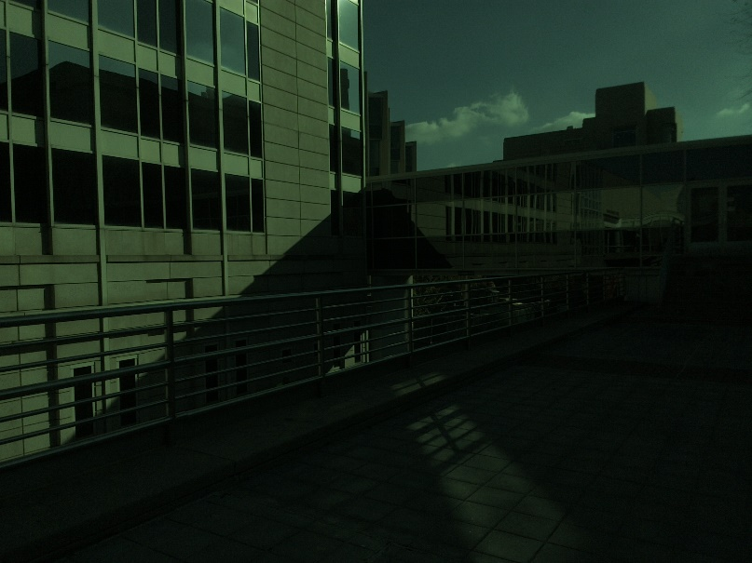

Figure 2. exposure time= 134400e-09 s

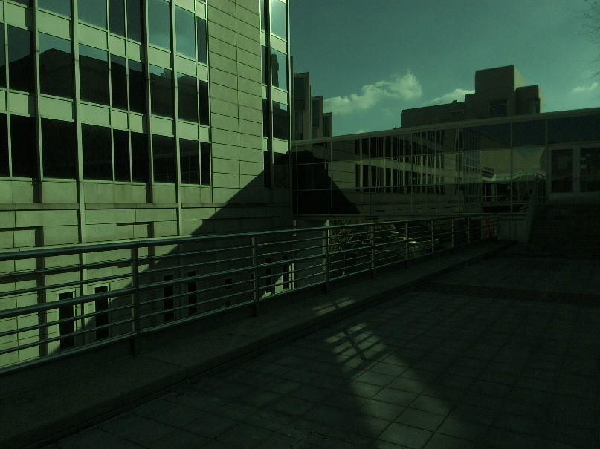

Figure 3. exposure time= 268800e-09 s

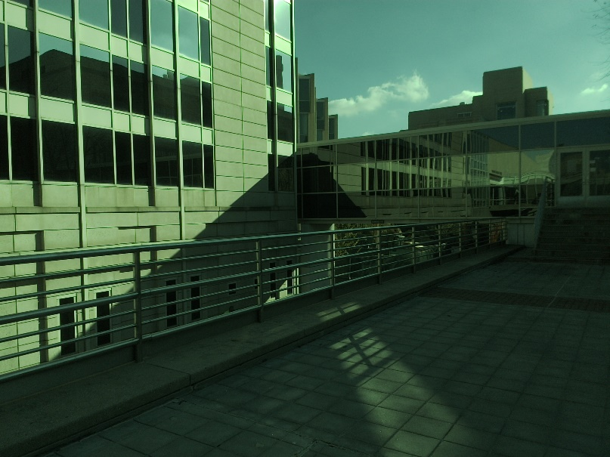

Figure 4. exposure time= 537600e-09 s

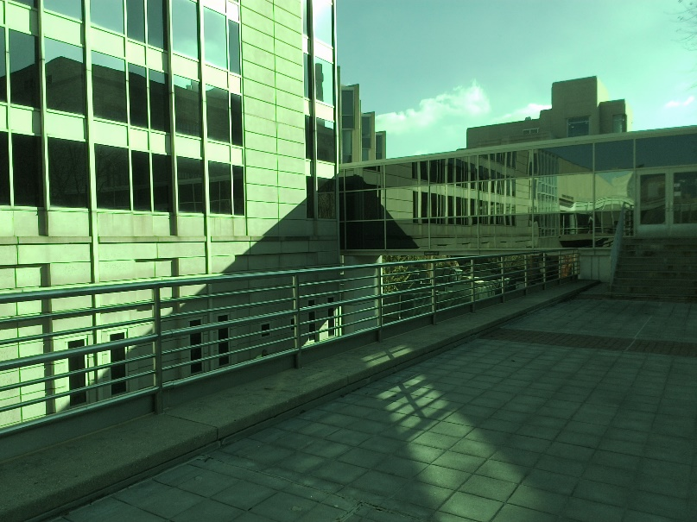

Figure 5. exposure time= 1075200e-09 s

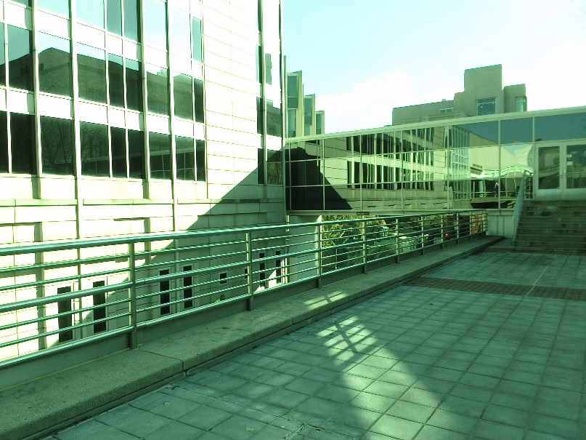

Figure 6. exposure time= 2150400e-09 s

Question 2. Write a program to find the camera response curves for the shield tablet (2 Points)

Answer:

When increasing the value of l, the fitted data becomes more compact and the response cure gets smoother. Results of l=0.1,3,5 of red channel and l=5 of red, green and blue channel are as follows. The rest of processing is based on l=5.

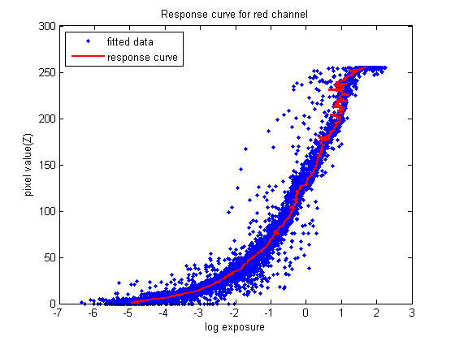

Figure 7. l=0.1

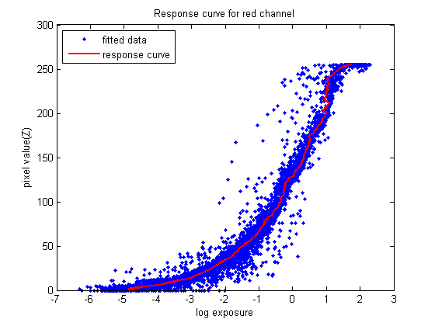

Figure 8. l=3

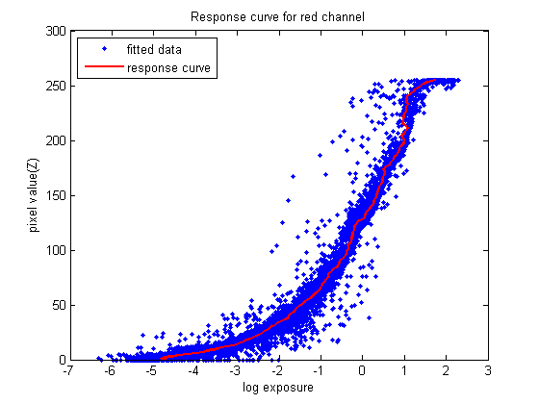

Figure 9. l=5



Figure 10. l=5 red channel

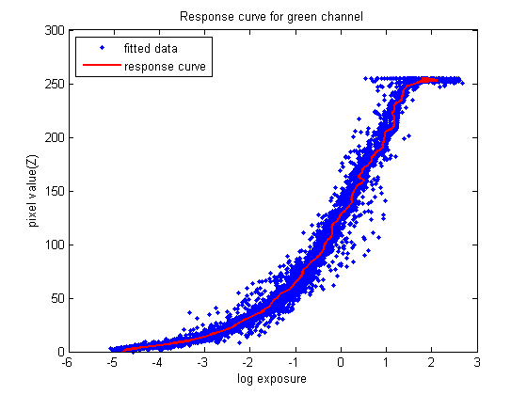

Figure 11. l=5 green channel

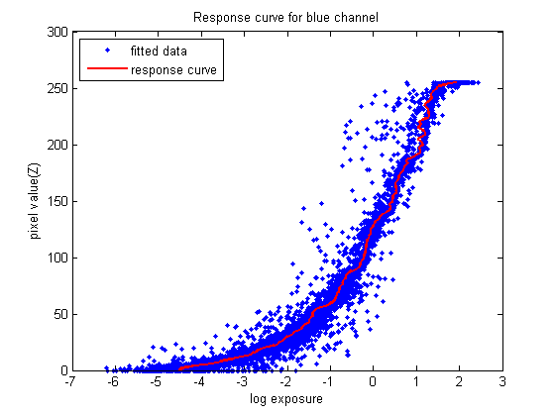

Figure 12. l=5 blue channel

Matlab Codes

clear;

clc;

B=[67200;

134400;

268800;

537600;

1075200;

2150400

];

B=B*10^-9;

k=size(B,1);

for i=1:k

B(i)=log(B(i));

end

Io=cell(k,1);

Ior=cell(k,1);

Iog=cell(k,1);

Iob=cell(k,1);

Icr=cell(k,1);

Icg=cell(k,1);

Icb=cell(k,1);

p=randperm(1000);

for k=1:6

imgname=strcat('D:\Courses Files\Introduction to Computational Photography\HW4\新建文件夹\',num2str(k),'.jpg');

Io{k}=imread(imgname);

Ior{k}=Io{k}(:,:,1);

Iog{k}=Io{k}(:,:,2);

Iob{k}=Io{k}(:,:,3);

Icr{k}=Ior{k}(339,:);

Icg{k}=Iog{k}(339,:);

Icb{k}=Iob{k}(339,:);

end

[gr]=Responsecurve(Icr,B,1,5);

[gg]=Responsecurve(Icg,B,2,5);

[gb]=Responsecurve(Icb,B,3,5);

function [g]=Responsecurve(I,B,r,l)

RGB={' red';' green';' blue'};

Z=zeros(size(I{1},1)*size(I{1},2),size(I,1));

X=zeros(size(I{1},1)*size(I{1},2),size(I,1));

for i=1:size(I,1)

Z(:,i)=reshape(I{i},size(I{1},1)*size(I{1},2),1);

end

[g,lE]=gsolve(Z,B,l);

for i=1:size(I{1},1)*size(I{1},2)

for j=1:size(I,1)

X(i,j)=lE(i)+B(j);

end

end

ZX(:,1)=reshape(X,size(X,1)*size(X,2),1);

ZX(:,2)=reshape(Z,size(Z,1)*size(Z,2),1);

figure();

plot(ZX(:,1),ZX(:,2),'.','color','b');

hold on

y=0:1:255;

plot(g(y+1),y,'-','color','r','LineWidth',2);

legend('fitted data','response curve','location','northwest');

xlabel('log exposure');

ylabel('pixel value(Z)');

imgname=strcat('Response curve for',RGB(r),' channel');

title(imgname);

end

Question 3. Recover the HDR radiance map of the scene (3 Points)

Answer:

The HDR radiance maps of red, green and blue channel are as follows.

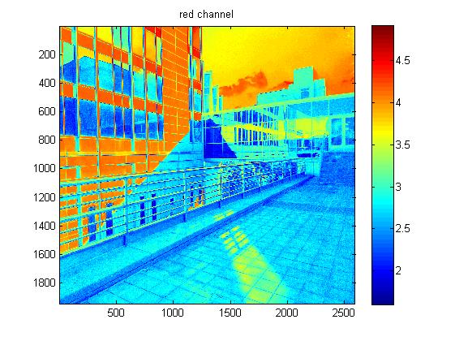

Figure 13. red channel

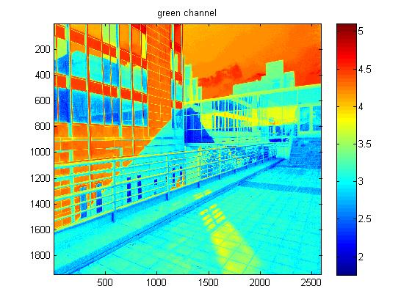

Figure 14. green channel

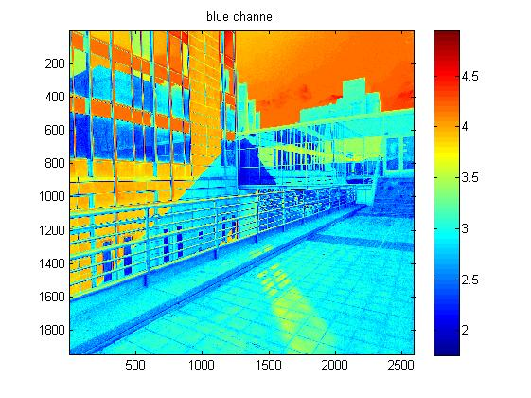

Figure 15. blue channel

The dynamic ranges of my scene are 104 for red channel, 104 for green channel and 103 for blue channel.

Matlab Codes

%%%%%% HDR radiance map %%%%%%

[Er,Er10,Ero]=map(Ior,B,gr);

[Eg,Eg10,Ego]=map(Iog,B,gg);

[Eb,Eb10,Ebo]=map(Iob,B,gb);

figure(),imagesc(Er10);colorbar;title('red channel');

figure(),imagesc(Eg10);colorbar;title('green channel');

figure(),imagesc(Eb10);colorbar;title('blue channel');

function [E,E10,Eo]=map(I,B,g)

m=size(I{1},1);

n=size(I{1},2);

E=zeros(m,n);

for i=1:m

for j=1:n

for k=1:size(B,1)

gz=g(I{k}(i,j)+1);

E(i,j)=E(i,j)+gz-B(k);

end

E(i,j)=E(i,j)/5;

end

end

E10=log10(exp(E));

Eo=exp(E);

end

Question 4. Implement a tone mapping algorithm to display your HDR image (5 Points)

Answer:

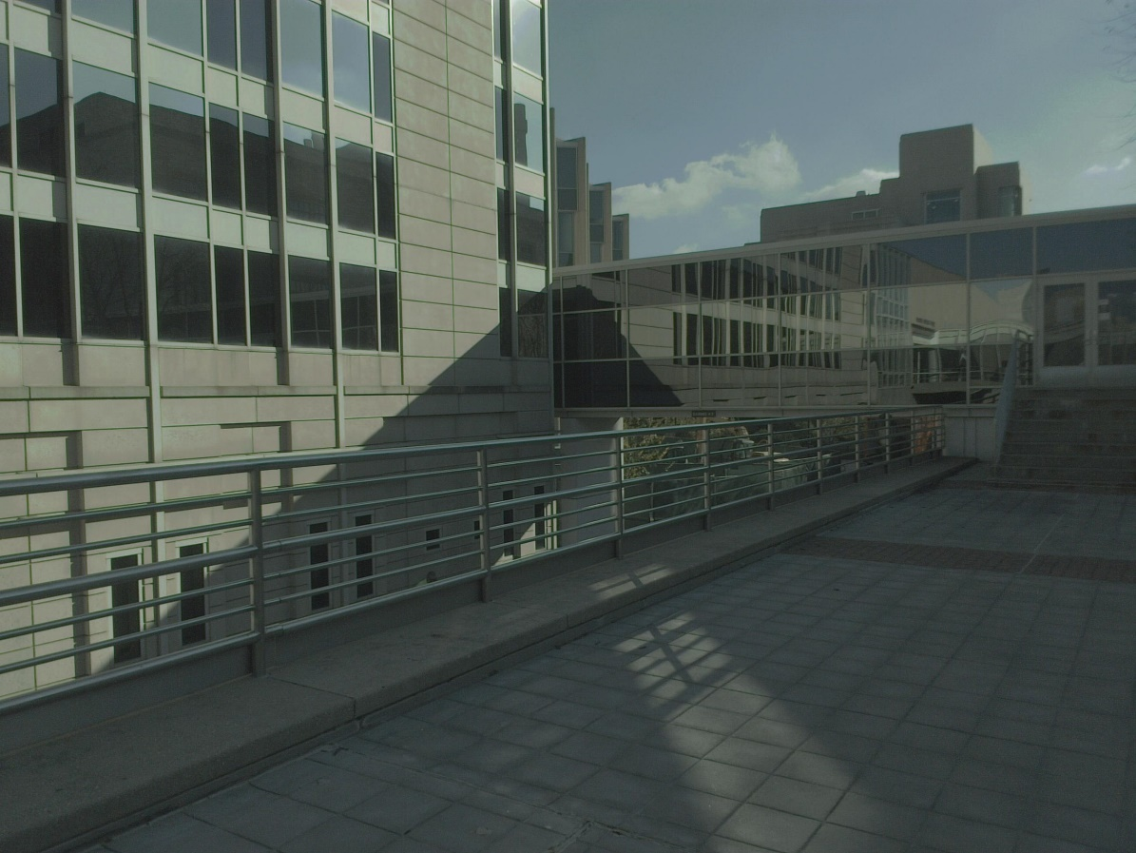

Figure 16. gamma correction γ=0.3

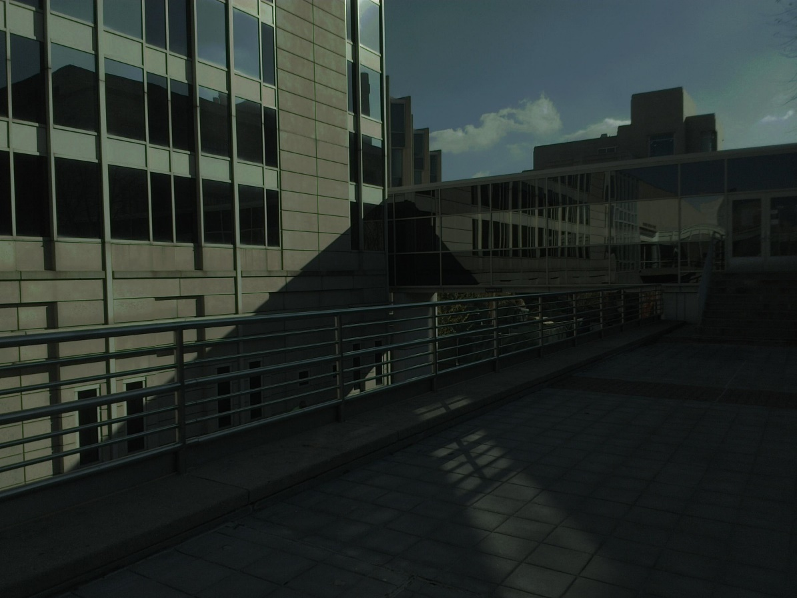

Figure 17. gamma correction γ=0.5

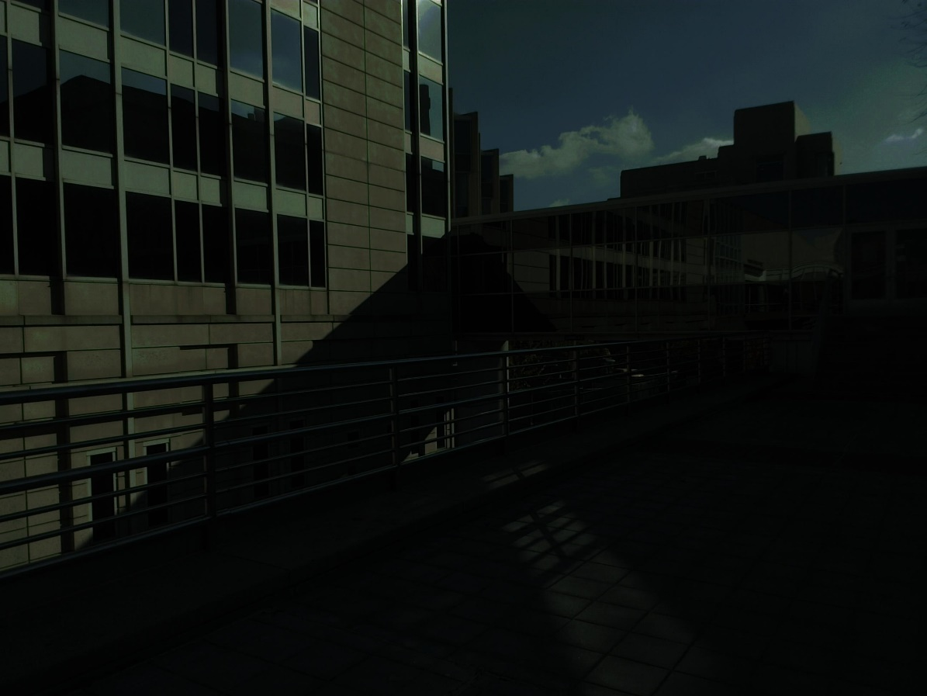

Figure 18. gamma correction γ=0.8

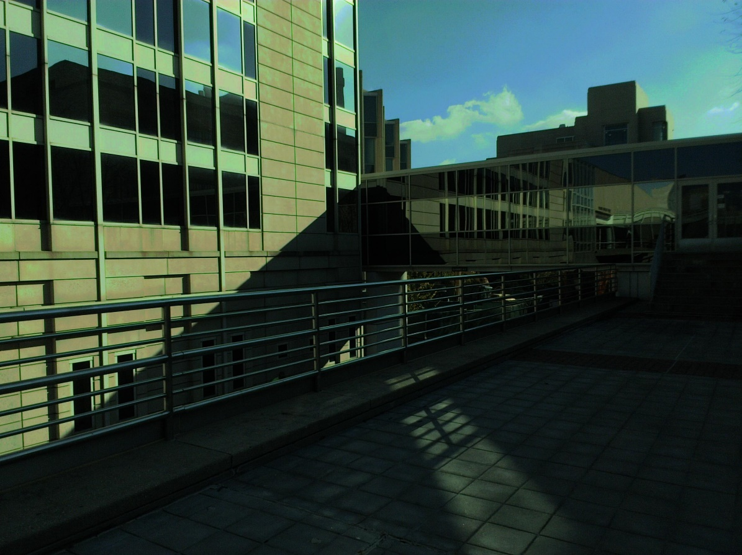

Figure 19. tone mapping algorithm a=0.18

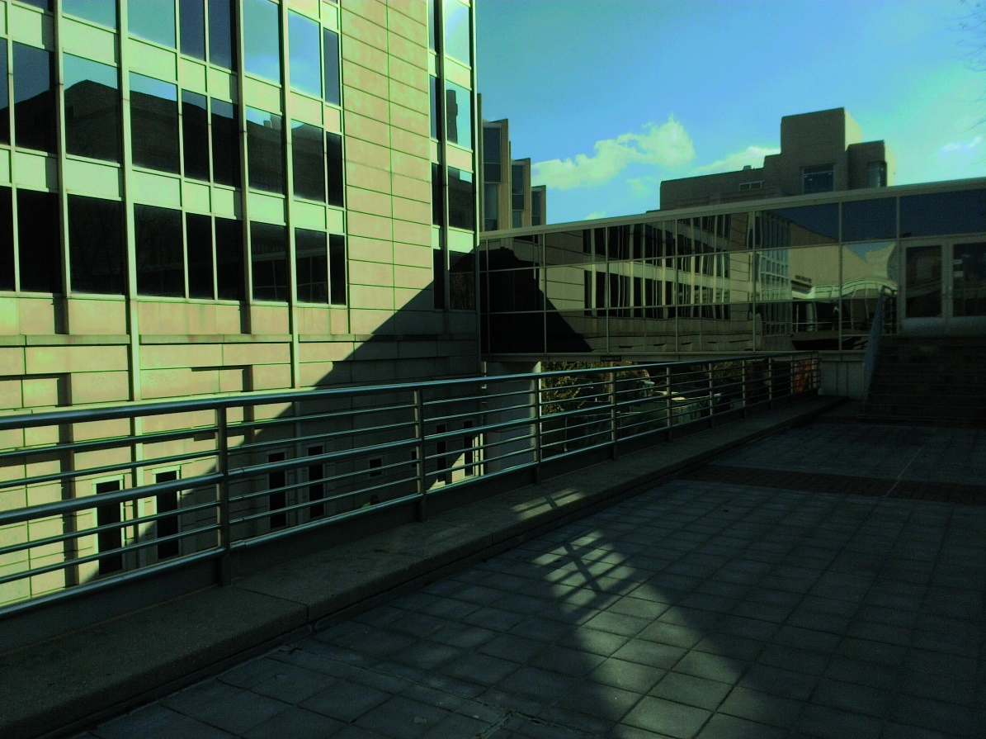

Figure 20. tone mapping algorithm a=0.28

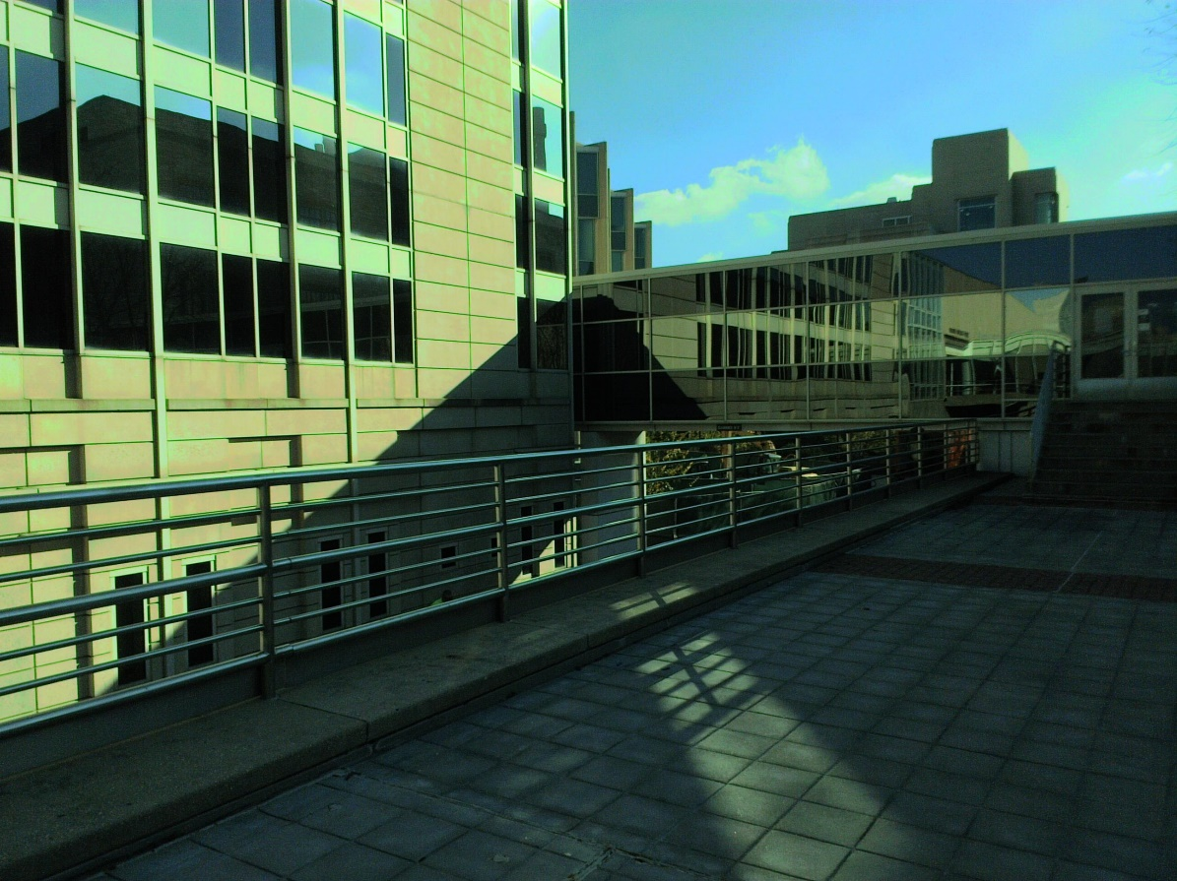

Figure 21. tone mapping algorithm a=0.38

From the results above, we can see that when a=0.38 and γ=0.5, we can obtain relative high quality images.

Matlab Codes

%%%%%% HDR image%%%%%%

[Ergamma,Ernorm]=HDRimage(Ero,0.3);

figure(),imagesc(Ergamma);colorbar;

[Eggamma,Egnorm]=HDRimage(Ego,0.3);

figure(),imagesc(Eggamma);colorbar;

[Ebgamma,Ebnorm]=HDRimage(Ebo,0.3);

figure(),imagesc(Ebgamma);colorbar;

Enormrgb(:,:,1)=Ernorm;

Enormrgb(:,:,2)=Egnorm;

Enormrgb(:,:,3)=Ebnorm;

Egamma(:,:,1)=Ergamma;

Egamma(:,:,2)=Eggamma;

Egamma(:,:,3)=Ebgamma;

L=rgb2gray(Enormrgb);

Lavg=0;

for i=1:size(L,1)

for j=1:size(L,2)

Lavg=Lavg+log(L(i,j));

end

end

Lavg=exp(Lavg/(size(L,1)*size(L,2)));

T=0.28/Lavg.*L;

Ltone=T.*(1+T./(max(max(T)))^2)./(1+T);

M=Ltone./L;

Rnew=M.*Ernorm;

Gnew=M.*Egnorm;

Bnew=M.*Ebnorm;

New(:,:,1)=Rnew;

New(:,:,2)=Gnew;

New(:,:,3)=Bnew;

figure(),imshow(New);

title('New');

figure(),imshow(Egamma);

title('Gamma');

figure(),imshow(Enormrgb);

title('Enormrgb');

imwrite(New,'New.jpg','jpeg');

imwrite(Egamma,'Gamma.jpg','jpeg');

imwrite(Enormrgb,'Enormrgb.jpg','jpeg');

function [Egamma,Enorm]=HDRimage(E,r)

Enorm=(E-min(min(E)))./(max(max(E))-min(min(E)));

m=size(E,1);

n=size(E,2);

Egamma=zeros(m,n);

for i=1:m

for j=1:n

Egamma(i,j)=Enorm(i,j)^r;

end

end

end

Problems encountered:

1. The pictures captured by the tablet are somehow strange. We all don`t know why they appear to be kind of green.
2. The dynamic of the radiance maps is lower than 106. Maybe it is because the features of the scene doesn`t own a wide range radiance.